**Kestrel AI: Natural Language SQL & Visualization Generator Demo**

**Input:**

Kestrel AI is an advanced tool that seamlessly translates natural language queries into SQL statements while also generating insightful visualizations. For example, when a user inputs a query like **"Show me the top 10 tech companies by market cap,"**

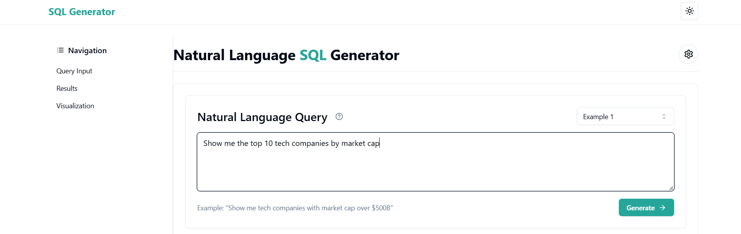

**Fig 1.** User Input Query for Market Cap Analysis

Kestrel AI processes this request and outputs a structured SQL query that retrieves the relevant data. Additionally, it automatically generates a visualization, such as a bar chart or table, to present the results in an intuitive manner. This functionality enables users, even those without SQL expertise, to interact with complex datasets effortlessly and derive meaningful insights.

**Features:**

1. **Real-Time Data Retrieval**

* The system fetches up-to-date stock market information on various companies.
* Users can filter, sort, and refine results based on financial parameters.

1. **Comprehensive Financial Metrics:** The tool provides insights into multiple financial indicators such as:

* Market Capitalization (mktCap): Total value of a company’s outstanding shares.
* Sector & Industry: Classification of a company’s business domain.
* Profit Margin, Gross Margin, Operating Margin, Net Income Margin: Measures profitability.
* Revenue & Earnings Growth: Indicates business performance trends.
* Dividend Yield: Measures return to shareholders.
* Price-to-Earnings Ratio (peRatio): Valuation metric.
* Price-to-Book Ratio (pbRatio): Measures book value.
* Debt-to-Equity Ratio: Represents financial leverage.
* Return on Equity & Return on Assets: Shows efficiency of capital utilization.

**Output:**

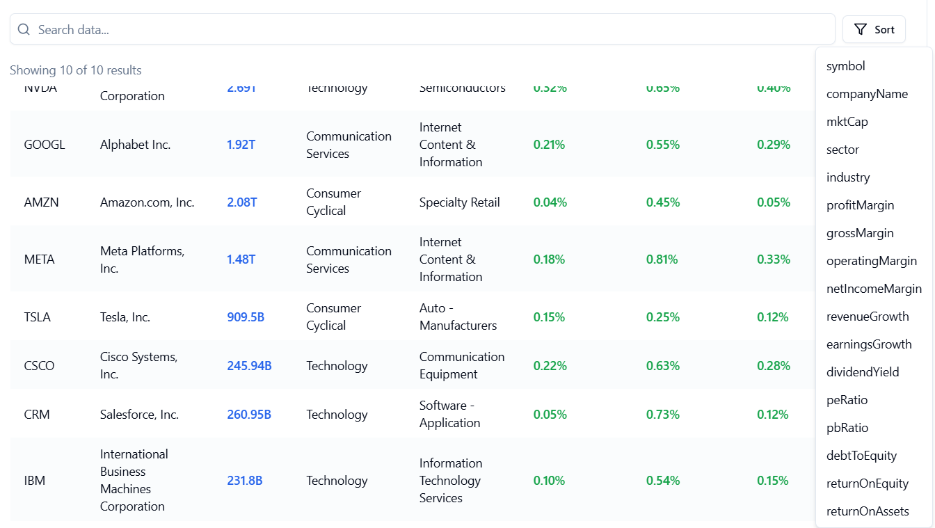

**Fig 2.** Customizable Sorting for In-Depth Company Analysis

1. **Automatic SQL Query Generation**

* For every user query, the tool automatically generates an SQL query to fetch the relevant data from the database.
* Example SQL Query for "Show me the top 10 tech companies by market cap":

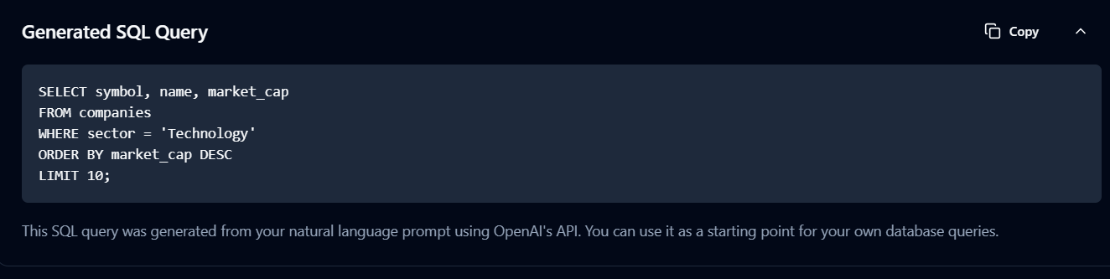

**Fig 3.** SQL Query Generation from NLP Input

1. **Interactive Data Visualization & Analysis**

* Users can visualize financial trends with interactive graphs and charts.
* Data can be modified, analyzed, and compared across companies.
* Users can export/download customized reports for deeper insights.

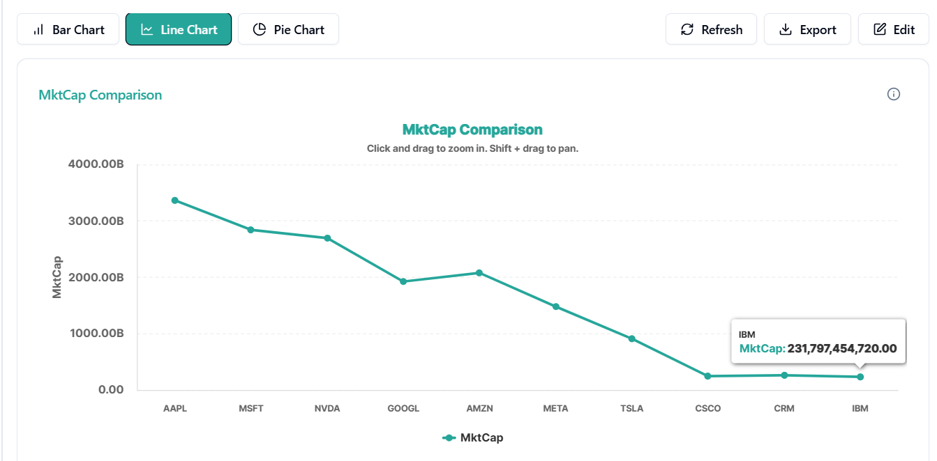

**Fig 4.** Market Cap Trends: Top 10 Companies (Line Graph)

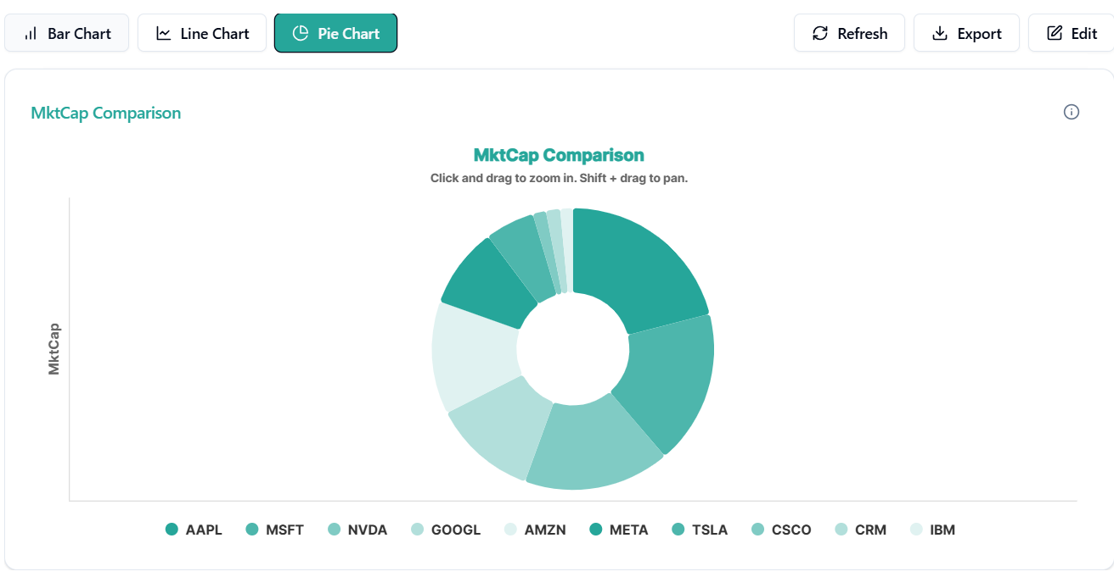

**Fig 5.** Market Share Distribution: Top 10 Companies (Pie Chart)

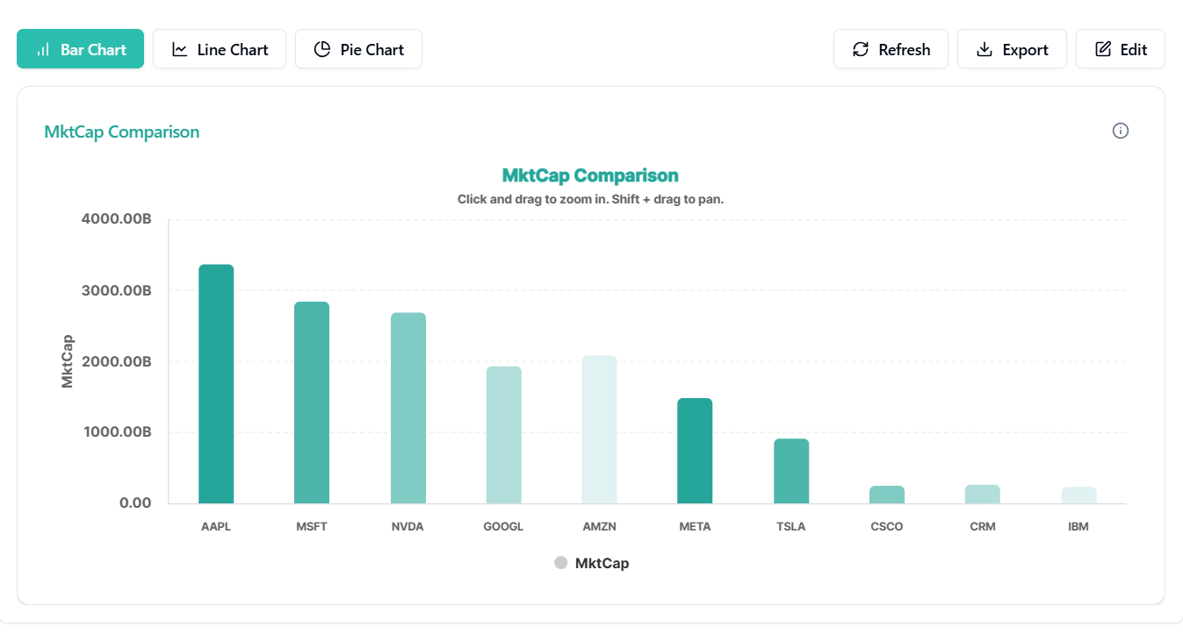

**Fig 6.** Comparative Market Cap Analysis: Top 10 Companies (Bar Chart)

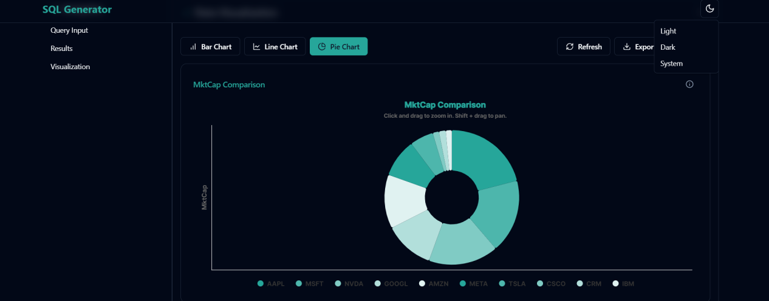

**Fig 7.** User Interface Flexibility: Light Mode vs Dark Mode

1. **Empowering Financial Research**

* The platform helps investors, researchers, and analysts make informed decisions.
* It provides a user-friendly interface for easy access to financial data.